**ALLAN LOITEMWA**

**673447**

**FIBONACCI SEQUENCE LAB**

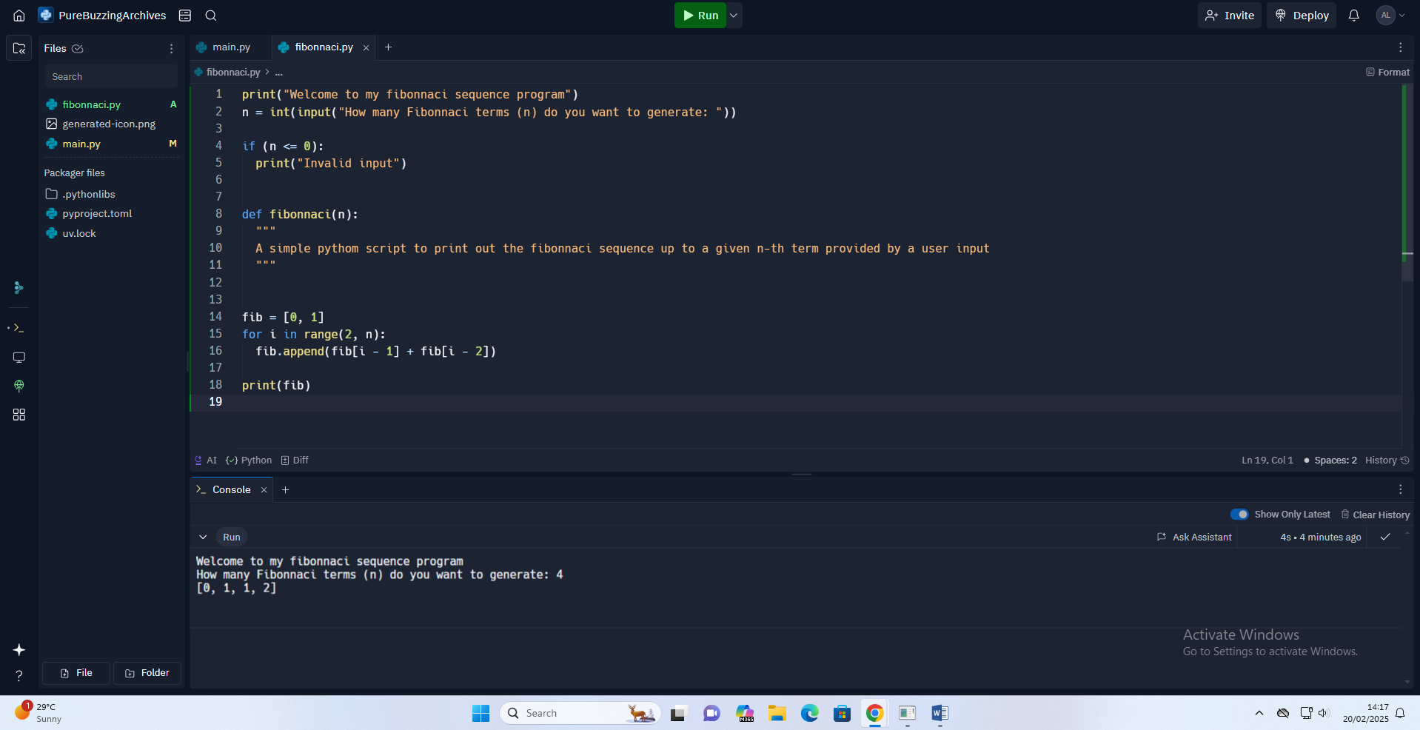

https://gist.github.com/alanlosenge/d5b72c1c0b95aad9fa2e45c036da6024